
FURTHER MATHEMATICS
TRIAL EXAMINATION 2
SOLUTIONS
2015

_____________________________________________________________________

Core - solutions

Question 1 (3 marks)
- From the dot plot we see that there are 4 farms which had a crop yield less than 2 tonnes per hectare.
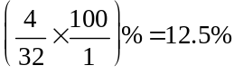
So 12.5% of the farms had a crop yield less than 2 tonnes per hectare.
(1 mark)
- We need to calculate 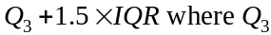 is the third quartile, and the IQR is the interquartile range.
Since there are 32 pieces of data, they divide neatly into 4 quartiles of 8 data values.
Counting in from the left, the eighth data value is 2 and so is the ninth so 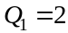.
Counting in from the right, the eighth data value is 4 and so is the ninth. 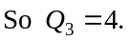
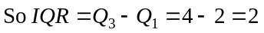
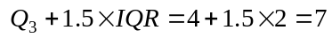 (1 mark)
(If you stop here you will lose a mark. We need to state that 8 is greater than this value and is hence an outlier.)
Since then the farm which has a crop yield of 8 tonnes per hectare is an outlier.
(1 mark)

Question 2 (5 marks)
- From the time series plot, the highest crop yield was about 3.1 tonnes per hectare.
This occurred in 2012.
(1 mark)
- i.
In 2020 the crop yield is predicted to be 3.65 tonnes per hectare (correct to 2 decimal places).
(1 mark)
- To find the crop yield in 2020 requires extrapolating, in other words, going beyond the data that we have which can be unreliable.
(1 mark)
- In 2008,
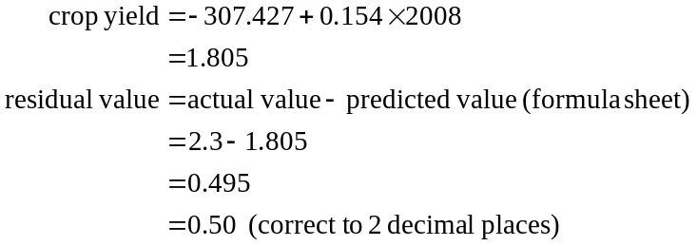
(1 mark)
- The gradient of the regression line tells us by how much the crop yield will increase each year. So that increase is 0.15 tonnes per hectare (correct to 2 decimal places). (1 mark)
Question 3 (3 marks)
- To obtain the coefficients in this equation enter the data in the table and then get your calculator to find 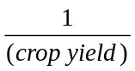 for each of the data values of the variable crop yield. This creates a third column of data. Calculate the least squares regression line equation using area as the independent variable (x-variable) and 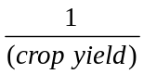 as the dependent variable (y-variable).
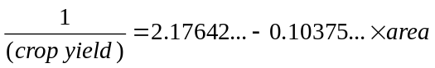
So 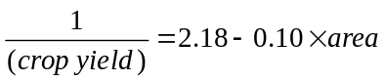, where the coefficients have been expressed correct to two decimal places. (1 mark)
- The dependent variable is . (1 mark)
- 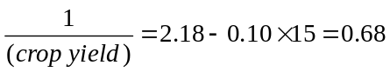
(1 mark)
Question 4 (4 marks)
- It is not appropriate to find the equation of the least squares regression line because the relationship between the variables crop yield and area is clearly not linear.
(1 mark)
- i. 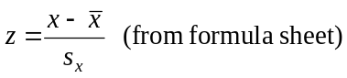
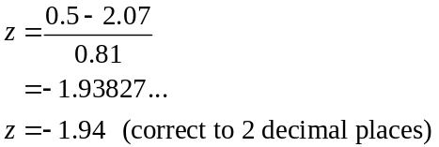
(1 mark)
  - Because we have a normal distribution (or at least one is assumed), we can use the rule.
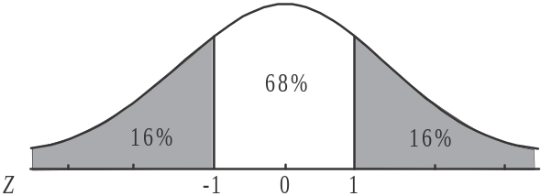

68% of data lies between one standard deviation either side of the mean.
Because of the symmetry of the normal curve, 16% of data is one standard deviation or more below the mean (and of course 16% of data is one standard deviation or more above the mean).
(1 mark)
    - For the variable area, the mean is 36.24 and the standard deviation is 17.46.
So one standard deviation below the mean is. Looking at the scatterplot we see that 7 farms actually have an area (over which the new type of crop is growing) that is less than 18.78 hectares.
(1 mark)
Module 1: Number patterns

Question 1 (4 marks)
- From the graph we see the museum had 10 000 visitors in year 1. (1 mark)
- From the graph 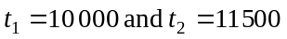.
So 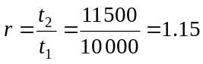 (1 mark)
- Since this is a geometric sequence with 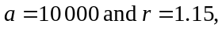 then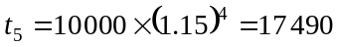.
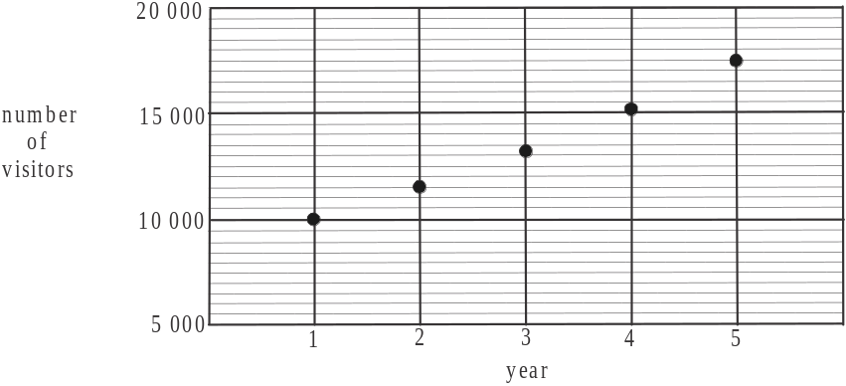

(1 mark)
- Since this is a geometric sequence with then
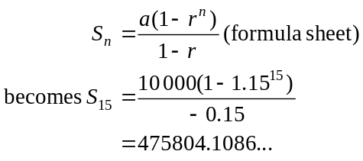
There were 475 804 visitors (to the nearest whole number) in years 1 – 15.
(1 mark)

Question 2 (5 marks)
- i. The difference equation generates a sequence that is arithmetic with a common difference of 70. We know that 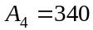, so working backwards, 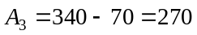
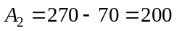
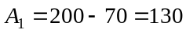, 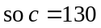.
(1 mark)
  - 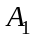 represents the number of new artefacts added to the collection at the end of 1921.
(1 mark)
  - Arithmetic sequence.
(1 mark)
- The terms of an arithmetic sequence are given by 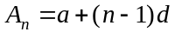.
For this sequence, 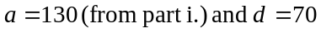.
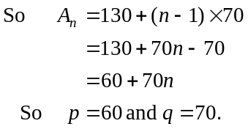
(1 mark) for p (1 mark) for q

Question 3 (6 marks)

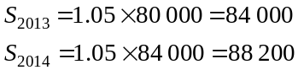
as required.
(1 mark)
This difference equation generates a geometric sequence where 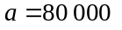 and .
Since the 1st term corresponds to 2012, then the 3rd term corresponds to 2014.
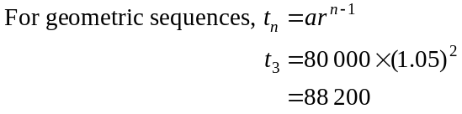
So 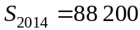 as required.
(1 mark)
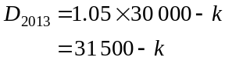
If the number of artefacts on display is to remain at 30 000, then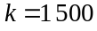 and so
1 500 artefacts need to be lent to other museums at the end of each year.
(1 mark)
- If
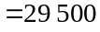
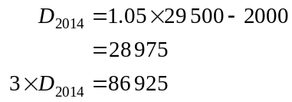
From part a.,
Since 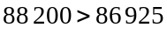 the number of artefacts held in storage at the end of 2014 would exceed the limit.
(1 mark)
- 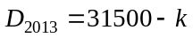, from part c.
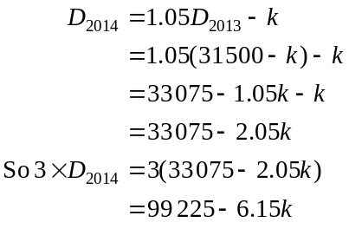
(1 mark)
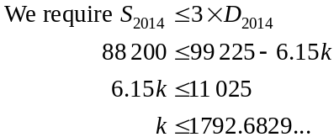
So the maximum number of artefacts that should be lent to other museums is 1792.
(1 mark)

Module 2: Geometry and trigonometry

Question 1 (4 marks)

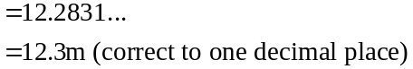
(1 mark)

- 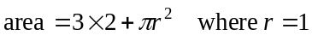
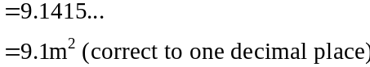
(1 mark)

- The vertical sides that wrap around the garden can be thought of as a rectangle with length equal to the perimeter of the base and width equal to 1.2m.
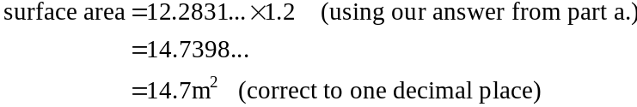
(1 mark)

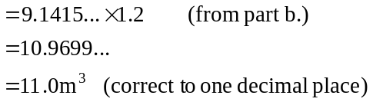
(1 mark)

Question 2 (5 marks)

a. i. In the right-angled 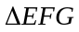,
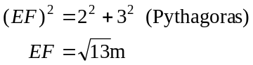
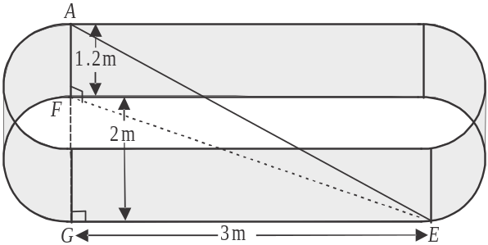

In the right-angled 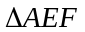,
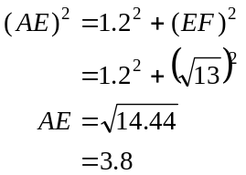

The length of the rod is 3.8m.
(1 mark) for EF (1 mark) for correct length
ii. Angle of elevation of point A from point E equals 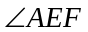.
Method 1
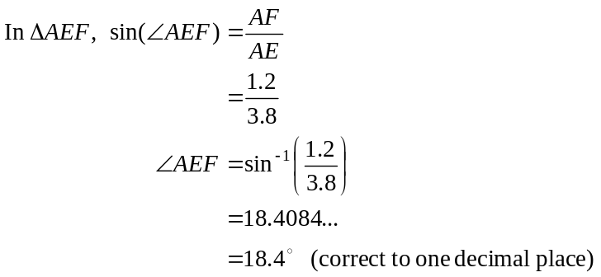
(1 mark)

Method 2
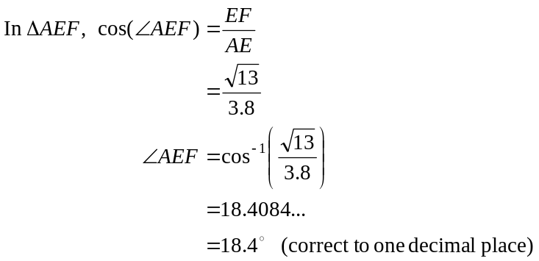
(1 mark)
Method 3
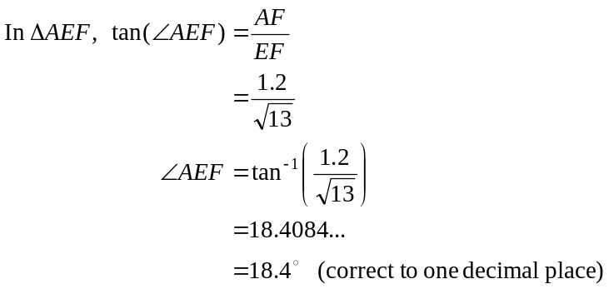
(1 mark)
- 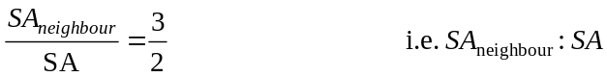
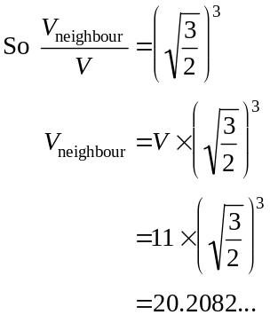
(1 mark)
So the neighbour will require 20.2 cubic metres of soil (correct to one decimal place).
(1 mark)

Question 3 (4 marks)
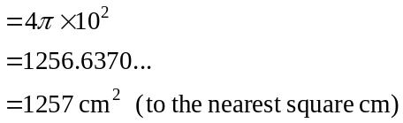
(1 mark)
- In right-angled triangle ACD,
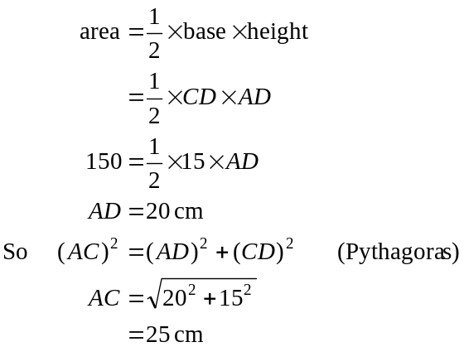
(1 mark)
- Note that is not a right-angled triangle.
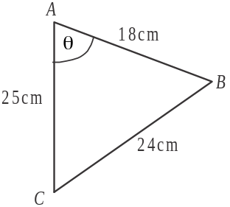
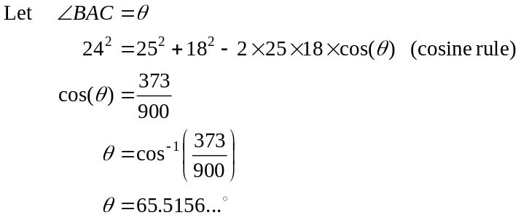
(1 mark)
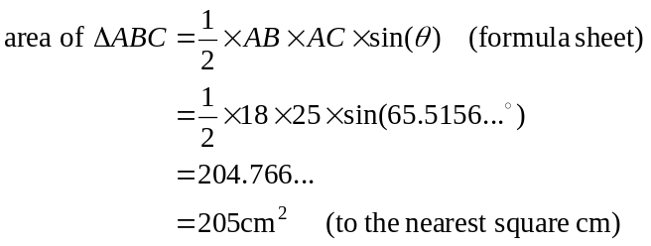
(1 mark)

Question 4 (2 marks)
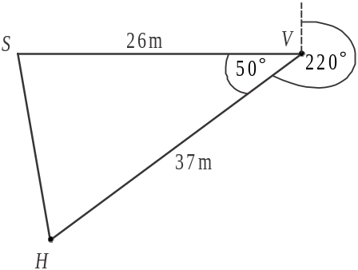
Draw a diagram.
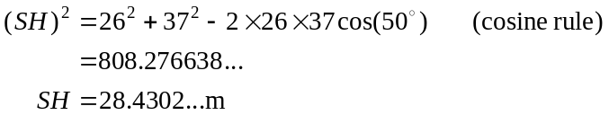
(1 mark)
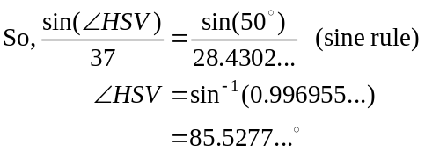
So the bearing of the house from the shed is equal to (to the nearest degree). (1 mark)
Module 3: Graphs and relations

Question 1 (6 marks)

a. i. Choose any two points that lie on the graph for example, the endpoints 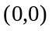
and 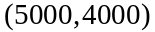.
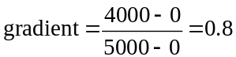
(1 mark)
(1 mark)
b.
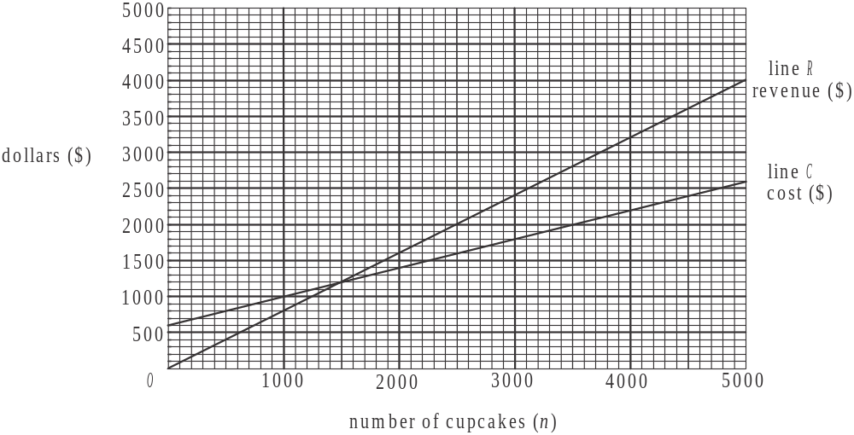

(1 mark)
c. Method 1 - graphically
From the graph, we see that the revenue line and the cost line intersect at the point 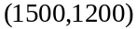 so the number of cupcakes that need to be supplied to break even is 1500.
(1 mark)
Method 2 – algebraically
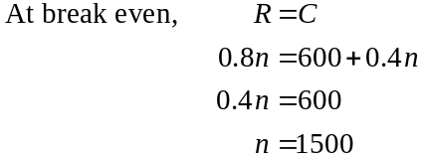
So the number of cupcakes needed to be supplied to break even is 1500.
(1 mark)
d. When 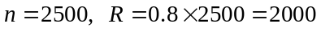.
When .
So when Killer Cakes supplies 2500 cupcakes, they make a profit of $400.
(1 mark) for “profit”
(1 mark) for $400

Question 2 (3 marks)
- If , then the 3rd rule applies to the revenue, that is,
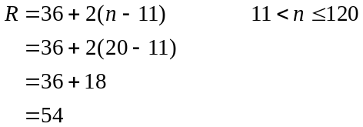
The revenue is $54. (1 mark)
- If , then the 2nd rule applies to the revenue, that is,
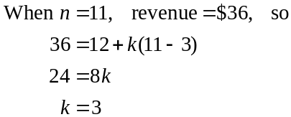
(1 mark)
- The cost of producing 30 cupcakes equals 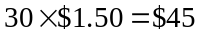.
The revenue from selling 30 cupcakes equals
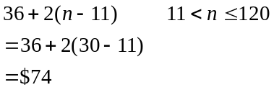
So the cake shop makes a profit of $29. (1 mark)

Question 3 (6 marks)
- Constraint 3 is 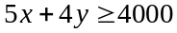.
It tells us that there is a minimum of 4000 minutes of staff time per week that can be used to produce cupcakes and muffins. (1 mark)

- and c. The graph below shows the line 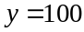 and the shading that satisfies constraints 1 – 4.
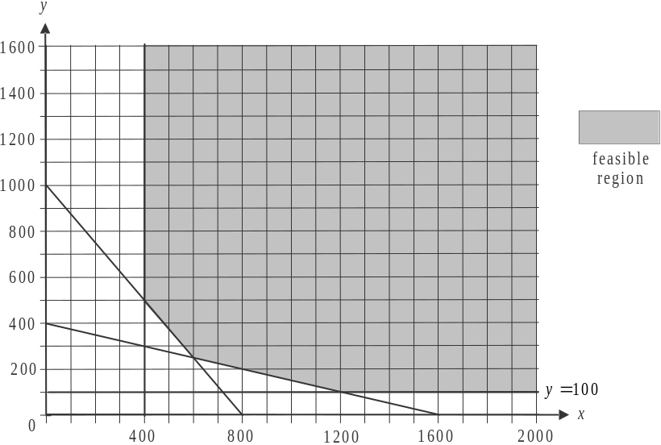

(1 mark) – correct line (1 mark) – correct shading
- From the graph, the corner points of the shaded region that satisfy the constraints and hence the contract, are .
The minimum total of coordinates for each of these points is .
So the minimum number of cupcakes and muffins combined is 850. (1 mark)
- Set up the objective function: 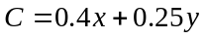
Substitute each of the corner points into this,
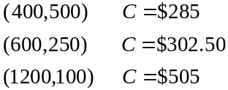
The minimum cost is $285. (1 mark)
- Looking at the graph, if the number of cupcakes was restricted to 400, the number of muffins that would need to be supplied is 500 or more so . (1 mark)
Module 4: Business-related mathematics

Question 1 (4 marks)

- 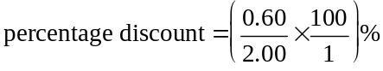
(1 mark)

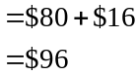
(1 mark)

- i. The balance after the withdrawal on 10 Feb 2015 is .
(1 mark)

- The minimum balance for the month is $82 147.60.
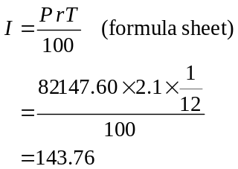
The simple interest earned is $143.76.
(1 mark)

Question 2 (2 marks)

- 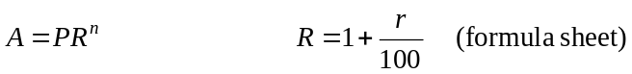
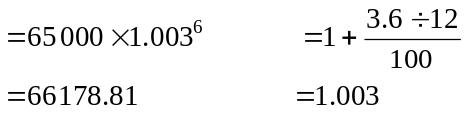
The amount of interest earned will be .
(1 mark)

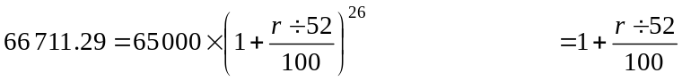
Using your CAS, solve this equation for r.
The first answer is clearly not feasible.
The annual interest rate is 5.2% (correct to one decimal place).
(1 mark)
Question 3 (5 marks)

- 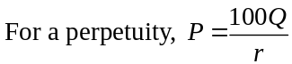
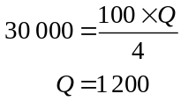
The annual amount of interest paid to the PFA would be $1200.
(1 mark)

    - The amount remaining invested in the perpetuity would be $30 000.
(1 mark)

- This is an investment annuity so use TVM.
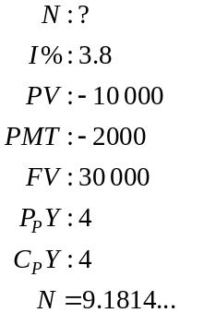
It will take 9 quarters (to the nearest quarter).
(1 mark)

- Start by finding the value of the original investment at the end of one year using TVM.
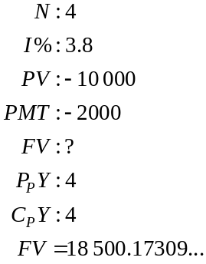
(1 mark)
Now, we need to find the new payment required, again using TVM.
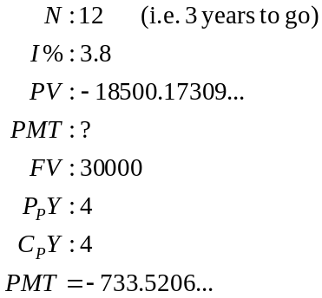
The PFA will need to make quarterly payments of $733.52.
(1 mark)

Question 4 (4 marks)

- 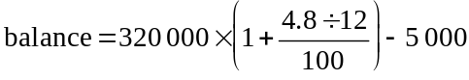
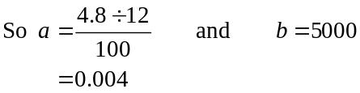
(1 mark)

- Using TVM.
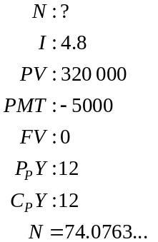
It will take 74 months (to the nearest month).
(1 mark)

- Using the equation from part a.,
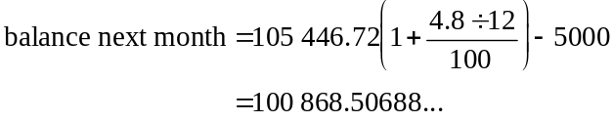
(1 mark)
The difference between this month’s balance and next month’s balance is 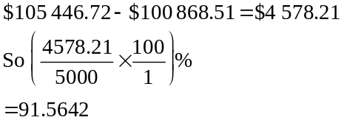
So 92% (to the nearest whole percent) of the next payment will be directed to reducing the balance of the loan. (The remainder of the payment pays the interest.)
(1 mark)
Module 5: Networks and decision mathematics

Question 1 (4 marks)

- The degree of the vertex at the Homestead waterhole is 4.
(1 mark)

- i. The shortest distance is 31km. (i.e. the route is West, Mine, South, Homestead, North, Town) which is .
(1 mark)

- The route is a Hamiltonian path.
(1 mark)

- An Eulerian circuit is a path that starts and finishes at the same vertex and passes through each edge just once. For an Eulerian circuit to exist then all the vertices must have an even degree. The only two vertices with odd degrees occur at West waterhole and North waterhole. The track between these two waterholes must be flooded.
(1 mark)

Question 2 (4 marks)

Area | Jimmy | Frankie | Peter | Lou
stable | 2 | 1 | 0 | 1
shed | 1 | 2 | 0 | 0
office | 1 | 0 | 2 | 3
homestead | 0 | 2 | 1 | 3
Table 2
(1 mark)
- It is now possible to allocate the areas because the minimum number of lines required to cover the zero elements in the table is 4, that is, the same number as the number of rows of the table.
(1 mark)

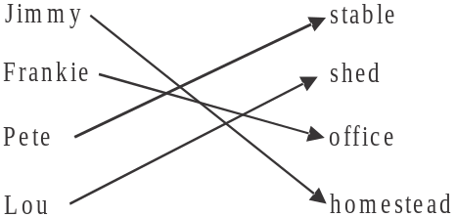

Note that there are five zeroes in the table so there should be 5 arrows, however, only one area can be allocated to each worker.
This means that the arrow between Pete and the shed is left off because the only area Lou can have is the shed whereas Pete can also be allocated the stable.
(1 mark)

- The minimum number of days is 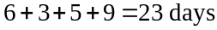 (using the figures in Table 1)
(1 mark)
Question 3 (7 marks)

The earliest and latest start times for each of the activities are shown below.
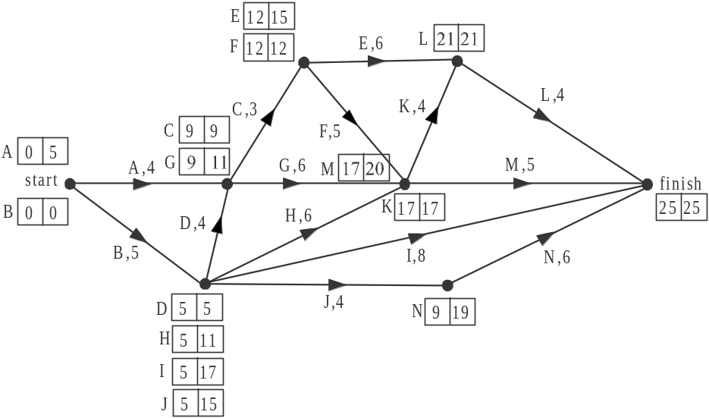

- The earliest starting time for activity K is 17 days.
(1 mark)

- The latest starting time for activity H is 11 days.
(1 mark)

- The activity which has the greatest float time is activity I. It’s earliest start time is 5 days and its latest start time is 17 days so it has a float time of 12 days.
(1 mark)

- The minimum number of days in which the new coolroom can be built is 25 days.
(1 mark)

- We are looking for activities with a float time of 7 days or more which are activities I, J or N.
(1 mark)

- Activity E has a float time of 3 days so delaying it by 2 days is not going to put it on the critical path. Those activities on the critical path after this delay are still B, D, C, F, K, L.
(1 mark)
- From part f., activity E has a float time of 1 day after the delay occurs. Therefore, crashing activity K by 1 day would reduce the completion time to 24 days because activity K is on the critical path. Crashing it by a second day would mean it would no longer be on the critical path. Therefore the least cost to obtain the largest reduction (of 1 day) is $250.
(1 mark)

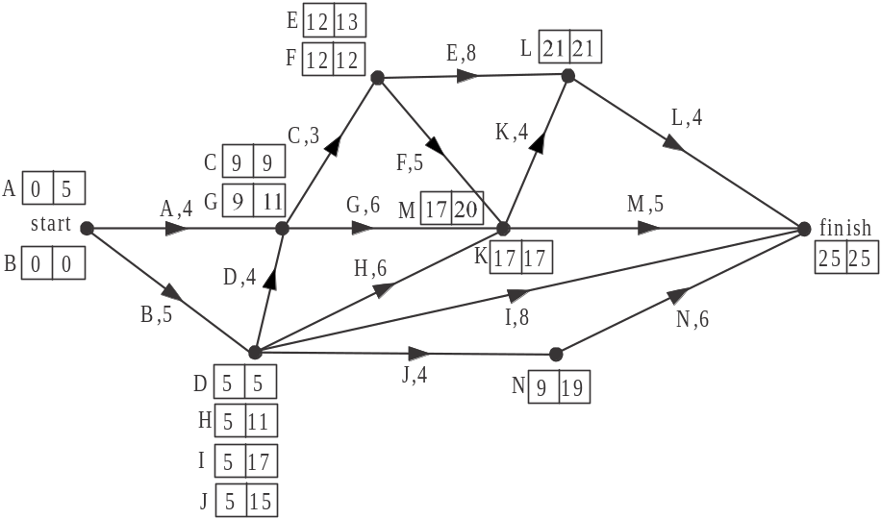

Module 6: Matrices

Question 1 (6 marks)

- Matrix N is of order (i.e. 2 rows and 3 columns).
(1 mark)

- There were 287 entrants in the 10km run.
(1 mark)

- There were entrants in a running event in 1996.
(1 mark)

- is not defined because matrix C has 1 column which is not equal to the number of rows that matrix N has, that is, matrix N has 2 rows.
(1 mark)

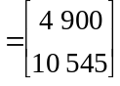
using your calculator.
(1 mark)

- The element in the second row of matrix P is 10 545 and it represents the total amount, in dollars, paid by the entrants in the 3 running events at the 1996 fundraiser.
(1 mark)

Question 2 (5 marks)

- 30% enter a different running event.
(1 mark)
- 20% of the employees who entered the 20km event one year changed their event the next year. Of these 5% went to the 5km event. So 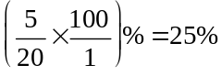.
So 25% of employees who entered the 20km one year but changed the following year, changed to the 5km event.
(1 mark)

- From the transition diagram we see that from one year to the next, 25% of employees change from the 10km run to the 20km run. So employees changed.
(1 mark)

- 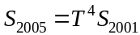
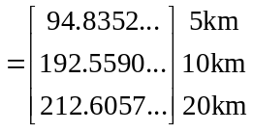
So 95 employees (to the nearest whole number) entered the 5km event in 2005.
(1 mark)

- 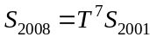
(1 mark)
Question 3 (4 marks)

- 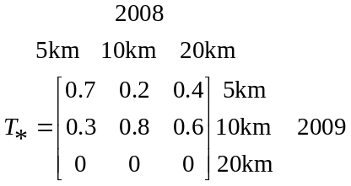
The missing entry is 0.6.
Note that the columns of a transition matrix should add to give 1.
(1 mark)

- Of the group of employees who ran the 10km event in 2008, 25% were expected to run the 20km event in 2009 (using T). However, because the 20km event couldn’t be staged and using matrix 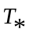, we see that 15% were expected to instead enter the 5km event (and the remaining 10% were expected to run again in the 10km event)
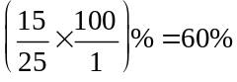
(1 mark)

- Start by finding the state matrix for 2008.
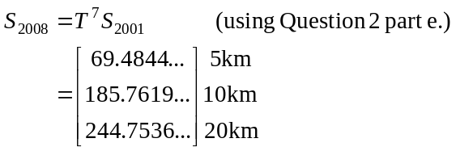
(1 mark)
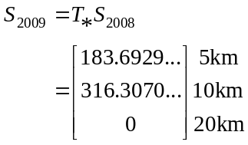
The number of employees expected to enter the 10km event in 2009 is 316 (to the nearest whole number).
(1 mark)

